OpenADR 2.0 Open Source Virtual Top Node - VTN User’s Manual
1026755
Open Source BSD 3-Clause License

OpenADR 2.0 Open Source Virtual Top Node - VTN User’s Manual

1026755
Software Manual, October 2013

DISCLAIMER OF WARRANTIES AND LIMITATION OF LIABILITIES
INSERT APPROPRIATE DISCLAIMER AUTOTEXT FOR EPRI.

Acknowledgments
The following organization(s), under contract to the Electric Power Research Institute (EPRI), prepared this report:
Nebland Software, LLC
859 Richborough Rd
Green Bay, WI
Principal Investigator
B. DuPont

Software Description
The EPRI OpenADR VTN server is an implementation of an open communication OpenADR VTN.
Description
This application was designed to support the role of a virtual top node (VTN) as defined in the OpenADR Alliance’s OpenADR 2.0 Profile Specification B Profile, updated July 1, 2013. OpenADR is a machine-to-machine interface that defines the information model, transport and security mechanisms and the manner in which data is exchanged between two end points. OpenADR 2.0 defines what and how information is communicated between an electricity service provider and customers, but it doesn’t purport to define how either end point uses the information. This server application is one example of how the OpenADR 2.0 specification can be applied. Included are features such as a graphical user interface to setup user accounts, assign clients (virtual end nodes VEN), define resources, market contexts, create and schedule demand response events.
Benefits and Value
This open source application was developed to provide the electric power industry with a open source research tool to demonstrate and test OpenADR 2.0. This application provides utilities with a tool to research the potential use of OpenADR 2.0 in different use-cases. The intent of making the source code available is to expose and fill potential of gaps in the OpenADR 2.0 specification that can only be identified through implementations.
Platform Requirements
EPRI’s OADR VTN was developed and tested on an Ubuntu 12.04 desktop and server. Limited testing has been done on Mac OSX. The software has not been tested on Windows Server, though all of the software used to run the OADR VTN runs on Windows.
Keywords
Demand Response
OpenADR 2.0
Virtual Top Node (VTN)
Virtual End Node (VEN)

Contents
1 Getting Started 1-1
Logging into the server 1-1
A Note on Accounts vs VENs 1-3
2 Configuring the server 1
The main purpose of a VTN is to schedule and manage events for demand response programs. In OpenADR, the three main entities involved are VTNs, Events and VENs. The VTN is the glue which supplies Events to a VEN. All of the configuration options covered below are intended to support sending events to VENs. 1
Accounts 1
VENs 1
Resource Types 2
Market Contexts 3
Groups 3
Events 4
Schedules 5
VTN Parameters 6
VTN Parameters 6
End Points 7
Test VEN 7
Test Case Prompts 7
3 configuring/managing vens 9
VEN Registration 9
VEN Settings 10
OpenADR Profile Settings 11
VEN Resources 11
Market Context Subscriptions 13
Reports 13
Report Identification 14
Report Requests 15
Opt Schedules 18
VEN Registration Details 19
4 The user menu Error! Bookmark not defined.
5 Creating Events 20
2 creating schedules 24
6 User ven management Error! Bookmark not defined.
7 Running Test cases against the test set 34
8 installation 34
Installation Notes 34
Setup and Configure the Server 34
Setup the Application 35
Setup and Configure Apache with SSL 36
Setup and Configure OpenFire (XMPP) Server with SSL 37
Installation Resources 37

Mandatory Software installation Information
Installation of EPRI Software at Client Site
EPRI develops software using a number of third party software products and tools that run on various operating systems and server platforms. Reports from the software industry suggest there are known security issues with some products and systems. EPRI recommends that, if you are using EPRI software, you review its use with your Information Technology (IT) department and their overall strategy to ensure that all recommended security updates and patches are installed as needed in your corporation. If you have any concerns please call the EPRI Customer Assistance Center (CAC) at 1-800-313-3774 (or email askepri@epri.com).
If you experience difficulties accessing the application
If you experience difficulties accessing the application after standard installation on Windows XP, Windows Vista and Windows 7, please consult your IT department personnel to have proper access permissions setup for your use. If the problem can not be resolved, please call the EPRI Customer Assistance Center (CAC) at 1-800-313-3774 (or email askepri@epri.com).

Getting Started
This manual assumes the user has access to an installed version of EPRI’s OpenADR VTN server. For installation instructions, see ‘EPRI VTN Installation Manual’.
This manual covers the functions of the web interface and is not intended to be a demonstration of the OpenADR protocol. To get a full understanding of OpenADR, the reader is encouraged to follow along with the demonstration document ‘EPRI OpenADR Demonstration’. This document demonstrates how VTNs and VENs interact through the OpenADR protocol using EPRI’s VEN and VTN software.
The VTN web UI has been tested with Firefox on Linux, Windows, and OS X, IE 10 on Windows 7, and Safari on OS X.

Logging into the server
The login screen is shown in figure 1-1.
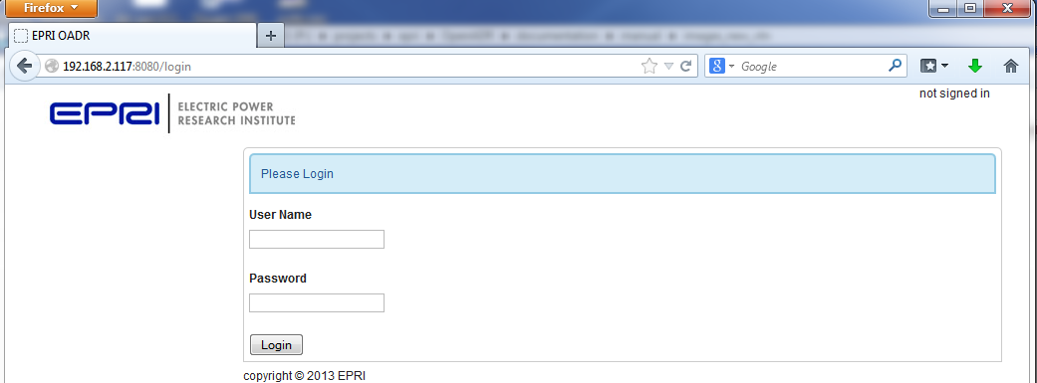
Figure 1-1
Login Screen
If you’re accessing the server from a fresh install, login as the default admin user:
Username: admin
Password: testing
If you are logging into EPRI’s server, your EPRI representative will supply you with a username and password.
Once logged into the server, you will be redirected to the dashboard. The dashboard shows which VENS are configured for the logged in user and what events target those VENs. Figure 1-2 shows a dashboard with two VENs (Test_VEN_Name, and TH_VEN) and the first VEN has one event.
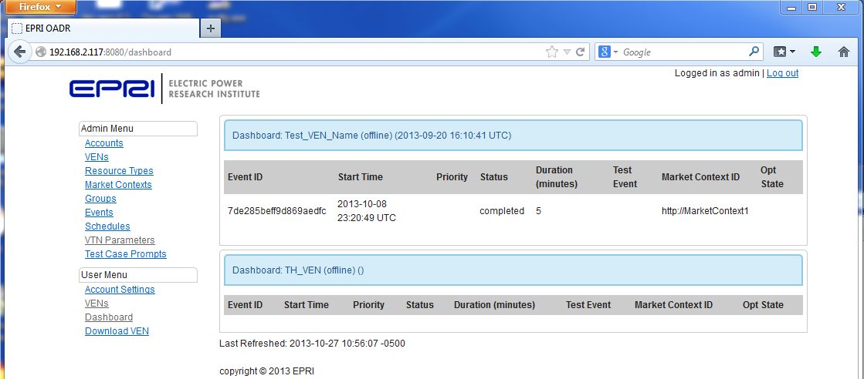
Figure 1-1
Dashboard
Non-admin users will see the user menu only. Admin users will see both the admin menu and the user menu.

Download the VEN
The User Menu contains a Download VEN link (see Figure 1-2). The software included in this download is an implementation of an OpenADR 2.0b Virtual End Node (VEN). This software can be used to test against the EPRI VTN, or any compliant VTN implementation.
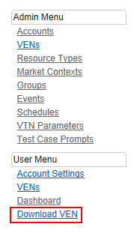
Figure 1-2
Download VEN Link
Please see the documentation directory in the VEN download for information on testing with the VEN.

A Note on Accounts vs VENs
The EPRI OpenADR VTN arranges an account as a high level entity which is used to manage any number of VENs. Non admin accounts can create any number of VENs for their account. Admin accounts can create VENs for any account.
The EPRI VTN draws a distinction between an account and a VEN which may be contrary to the OpenADR specification which treats an account and a VEN as the same entity. This does not make EPRI’s VTN incompatible with the specification.

Configuring the server
The main purpose of a VTN is to schedule and manage events for demand response programs. In OpenADR, the three main entities involved are VTNs, Events and VENs. The VTN is the glue which supplies Events to a VEN. All of the configuration options covered below are intended to support sending events to VENs.

The admin menu consists of the following options: Accounts, VENs, Resource Types, Market Contexts, Groups, Events, Schedules, VTN Parameters, and Test Case Prompts. Each of these options is covered in turn below.

Accounts
Clicking on the Accounts link brings up the account list page. From this page, the user can edit or view the details of an account, destroy an account, create a new account, or add a VEN to an account.

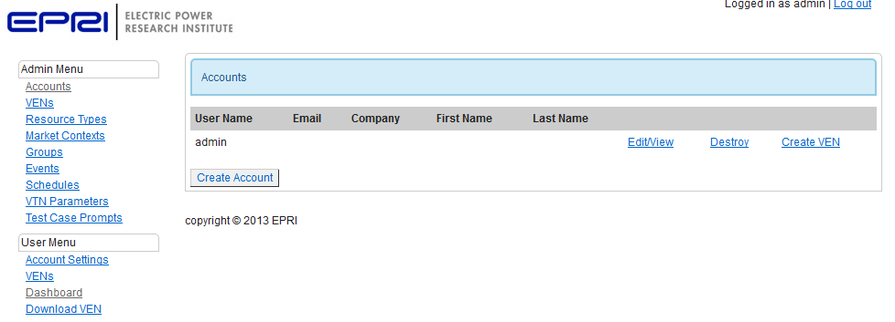
Figure 2-1
Account List Page

VENs
Clicking the VENs link brings up the VEN list page. From this page, the user can view/edit a VEN, destroy a VEN, or create a new VEN.
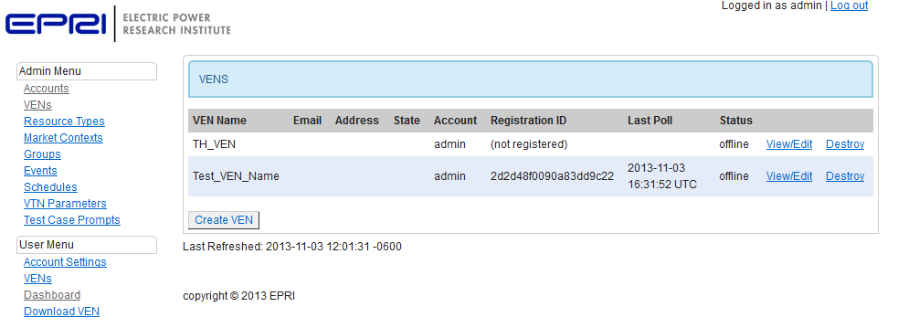
Figure 2-2
VEN List Page

Resource Types
From the Resource Types page, the user can add and remove resource types. Resource types are associated with resources.
From the VEN edit/view page, a user can add a resource to a VEN and assign a particular resource type to the resource.
When scheduling an event, the user can target specific resource types. Any VEN with a resource associated with the selected target resource type will receive the event.
For example, an admin can create a WATER_HEATER resource type and a WATER_HEATER resource to a set of VENs. The admin can then create an event that targets VENs with a WATER_HEATER by selecting WATER_HEATER as a target resource.
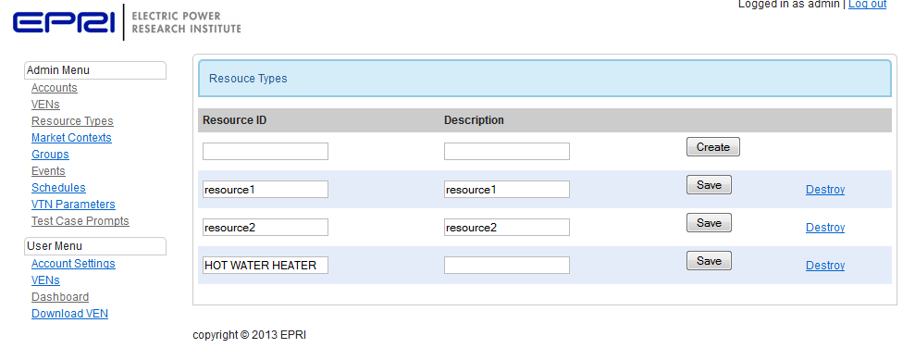
Figure 2-3
Resource Types List

Market Contexts
Market Contexts are Demand Response programs. Events are assigned to a particular demand response program or Market Context.
VENs can subscribe or unsubscribe to/from a Market Context from the VEN view/edit page. Subscribing to a Market Context assigns a unique party ID to the VEN and allows an event to target that party ID.
The OpenADR protocol does not define how details of a demand response program are exchanged between a VTN and VEN. All that can be configured for a Market Context is a name (intended to be a URL) and a description. Description is not required.
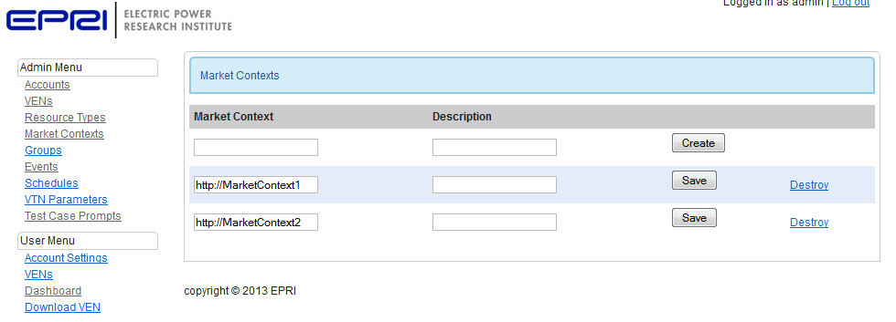
Figure 2-4
Market Context

Groups
Admins can create groups of VENs from the Groups page. The name of the group is arbitrary. By placing VENs into groups, an event can target multiple VENs by selecting the group as a target.
Groups in EPRI’s OADR VTN are based on accounts. Since a single account can have multiple VENS associated with it, adding an account to a group effectively adds all VENS in the account to the selected group.
Create a group: a group can be created by entering a unique name and a description, and clicking the create button.
Edit group membership: edit group membership by clicking the edit button next to the group. After clicking edit, a list of members and non-members will appear below the list of groups. To remove members from a group, select the checkbox next to the accounts that should be removed and click the Remove Accounts button. To add account, select the checkbox for the accounts to add and click add accounts. See figure 2-5.
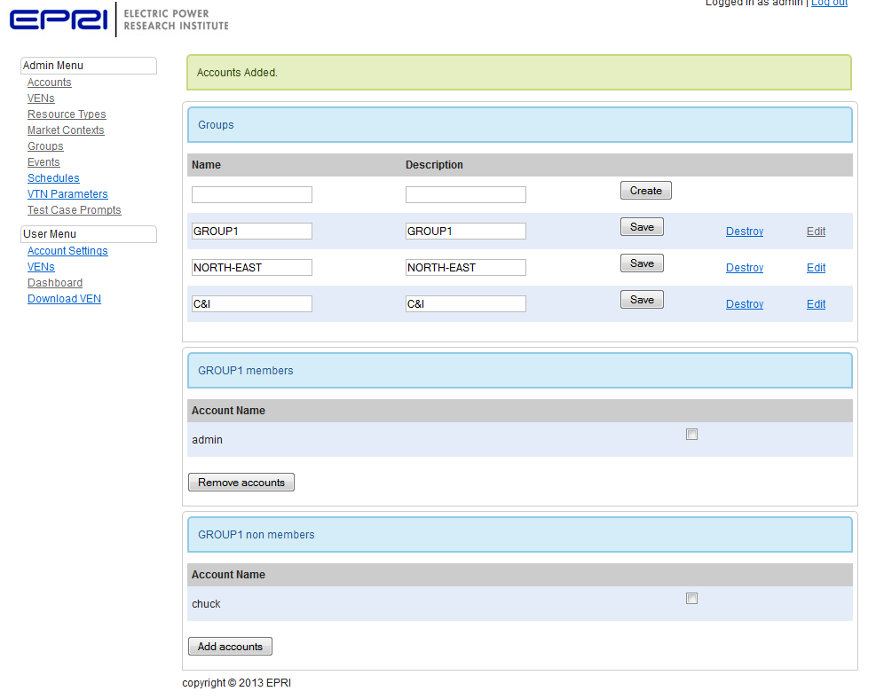
Figure 2-5
Edit Group Membership

Events
The events links shows a list of events. From the list page, the user can view/edit and destroy existing events, or create a new event. See figure 2-6.

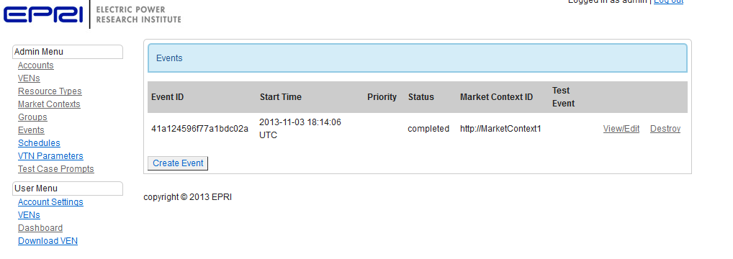
Figure 2-6
Event List
See Creating Events for more information.

Schedules
The Schedules link shows a list of schedules. The user can view/edit or destroy existing schedules or create a new schedule from this page.
Schedules are used to create recurring events. A schedule has all of the same properties as an event with the addition of the schedule properties: the schedule determines on what days of the week the event will be created. See figure 2-7.
After an event is created from a schedule, the event will appear in the list of events and it can be edited like any other event. See figure 2-6.
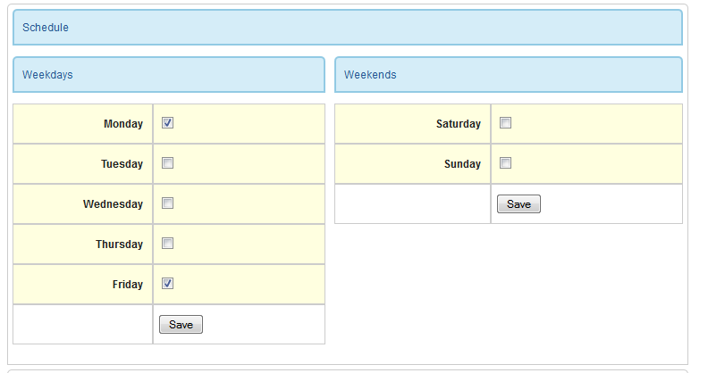
Figure 2-7
Editing a schedule
The edit schedule page is nearly identical to the edit event page. One key difference is the word TEMPLATE in the Event Settings header. See Figure 2-8.
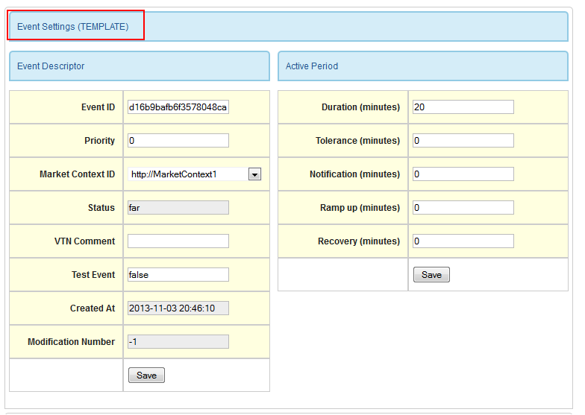
Figure 2-8
Editing a schedule: TEMPLATE signifies a schedule is being edited
Since editing the other properties of a schedule is identical to modifying an event, refer to Creating Events for information on editing other properties of a schedule.

VTN Parameters
The VTN Parameters page contains three sections: VTN Parameters, End Points, and Test VEN. See Figure 2-9.

VTN Parameters
VTN Parameters contains two fields that can be set:
VTN ID: ID used to identify this VTN. Once the ID is set and VENS have been registered, the ID should not be changed.

Poll Interval: Minimum poll time. Poll VENS should poll the VTN this often.

Profile b VENs receive both of these values as part of the registration process.

End Points
The URLs under End Points provide example service URLs that VENs will use to communicate with the server. The host part of this parameter is configured in
<app root>/config/environments/production.rb
Set the following parameter (at the bottom of the production.rb source file)
Rails.application.routes.default_url_options[:host] = <host and port>

Test VEN
The test VEN section provides a drop down list of VENs that are configured in the system. The VEN selected on this page will be used for testing with the Quality Logic test set. Events created under the ‘Test Case Prompts’ link will be created for the VEN that’s selected here.
Be sure to select a VEN that can be used for testing. With each new test case, all previous events for the VEN are removed from the system.
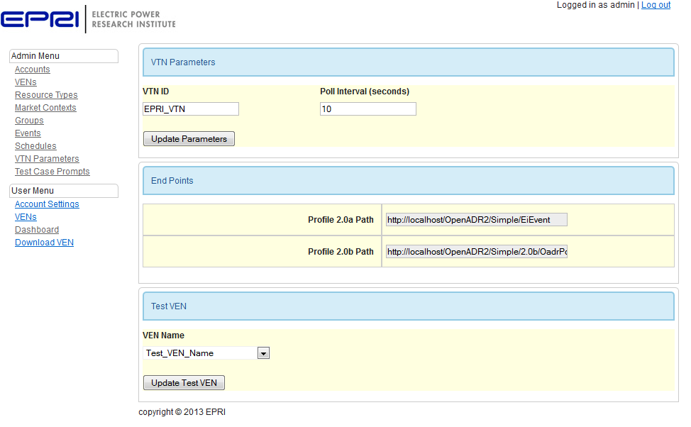
Figure 2-9
VTN Parameters

Test Case Prompts
Test case prompts aid in testing the VTN with the Quality Logic test harness event tests. If the prompts weren’t loaded during installation, only the Prompt Filter will be visible. See Figure 2-10. See the Setup the Application section of the installation instructions for information on how to load the test prompts.

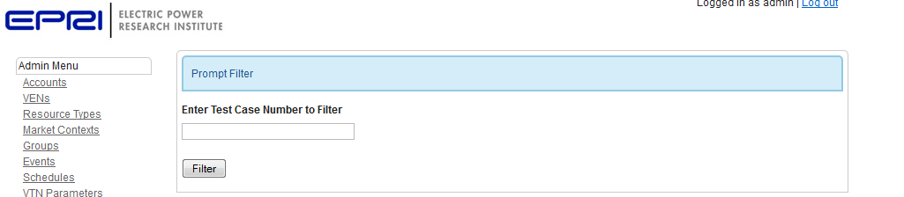
Figure 2-10
Test Case Prompts view if no prompts were loaded
If the prompts have been loaded, the screen will look like Figure 2-11.
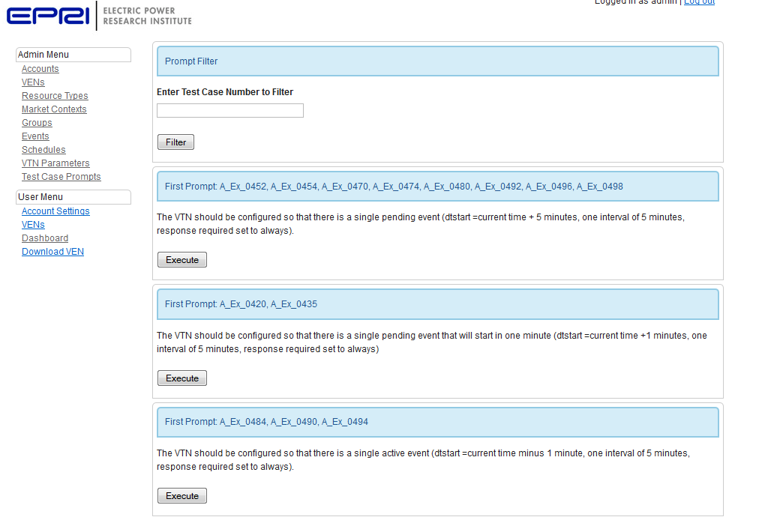
Figure 2-11
Test Case Prompts view when the prompts have been loaded. Only the first 3 prompts are shown in the image.
The Test Case Prompts page contains a filter at the top of the screen. The filter can be used to quickly find a test case prompt to execute. Simply type the test case number into the filter and click the filter button. The test case number is displayed to the user on the prompt screens displayed by the test harness. Figure 2-12 shows a sample prompt from the test harness. See Running Test Cases against the Test Set for more information.
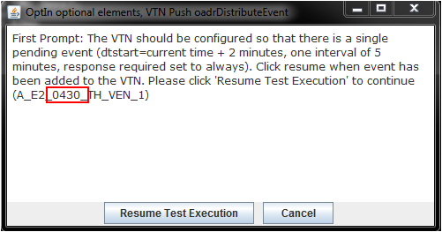
Figure 2-12
Example prompt from the test harness. The user would type 0430 into the filter to find the test case prompt(s) to execute in the EPRI OADR VTN.

Configuring/Managing VENs
The VEN view/edit page has a number of sections. Each section is covered in turn below.

VEN Registration
The top of the page contains two buttons: Queue VEN Reregister and Cancel VEN Registration. See Figure 3-1.
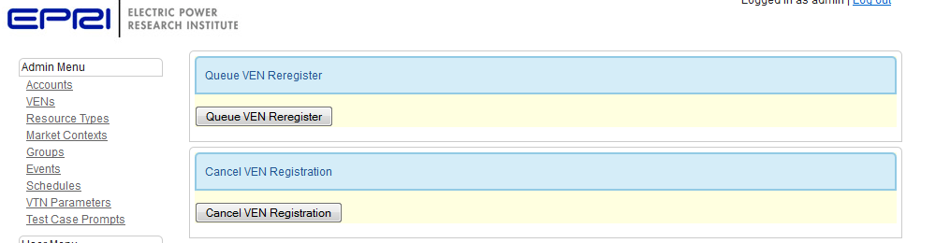
Figure 3-1
Reregister and Cancel registration
The first button will queue a reregistration message for poll VENs or push a reregistration message for push VENs. This message forces a VEN to go through the registration process again. If VTN registration information is changed, this feature can be used to force the VEN to reregister in order to receive the updated information.
The second button queues a cancel registration message for poll VENs and pushes a cancel registration message for push VENs. It is unclear how this exchange should be used by the VTN. If a VEN has a valid SSL certificate and the VEN has an entry in the EPRI VTN, the VEN will be able to reregister: canceling a registration does not block the VEN from communicating with the server.

VEN Settings
VEN Settings contains two sections: Identification and Capabilities. See Figure 3-2.
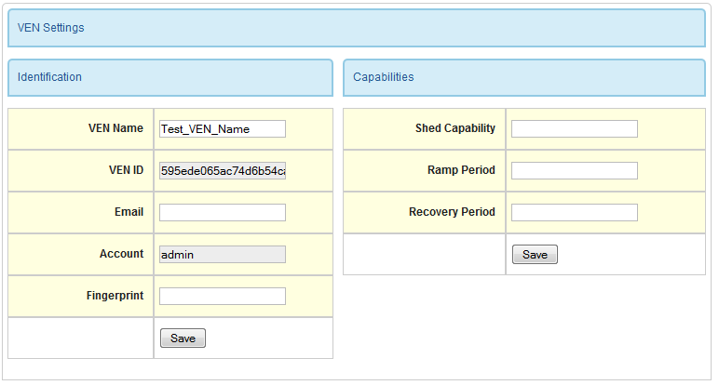
Figure 3-2
VEN Settings
The capabilities parameters can be used by the VTN to calculate the impact of a DR event. The values are currently not used by the system.
The identification parameters are used as the basis for allowing the VTN to identify a VEN. The VEN name is a human readable string that is assigned to the VEN. When a VEN registers with a VTN, the VEN will present its VEN Name. The VTN validates the SSL fingerprint and sends the VEN ID in response. After registering, the VEN will use its VEN ID in all communication with the server.
The fingerprint is an SSL fingerprint as defined in the OpenADR profile documents. The combination of a fingerpint and a VEN ID should be unique, meaning an SSL certificate is assigned to a particular VEN and not shared among multiple VENs.
A certificate that’s used with a different VEN Name or VEN ID is an indication of a compromised certificate. By blocking access, one compromised certificate does not endanger all VENs.

OpenADR Profile Settings
These settings are intended for 2.0a profile VENS. These settings are needed since profile 2.0a does not support registration. The OpenADR profile field must be set correctly in order for the correct messages to be generated for the VEN. See Figure 3-3.
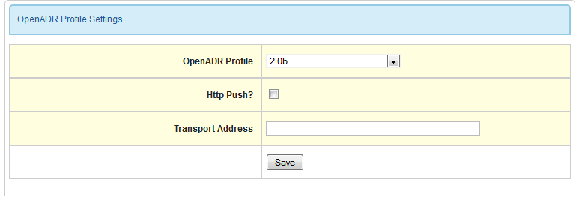
Figure 3-3
OpenADR Profiles Settings

VEN Resources
The VEN Resources section shows a list of resources that are associated with the VEN. OpenADR defines three classes of resources: generation, report only, and load shedding.
In profile 2.0b, a VTN can target certain resources in an event, or a signal in an event can target certain resources, and a VTN can request reports for resources. From this list, the user can view/edit or destroy a resource, or add a resource to the VEN. See Figure 3-4.
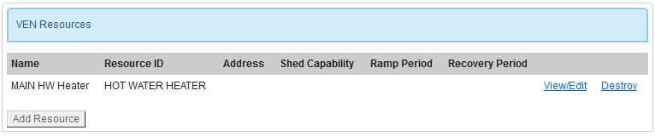
Figure 3-4
VEN Resources List
Clicking the view/edit link brings up the view/edit page for a resource. See Figure 3-5. The resource ID can be used to target VENs with a certain resource type. The example in Figure 3-5 shows a HOT WATER HEATER resource assigned to the VEN. The name of the resource is to help the VEN administrator identify the resource.
The other fields are not used by the system at this time, but they could be used to determine the impact of an event. Additionally, the location fields could be used to group VENs by location.
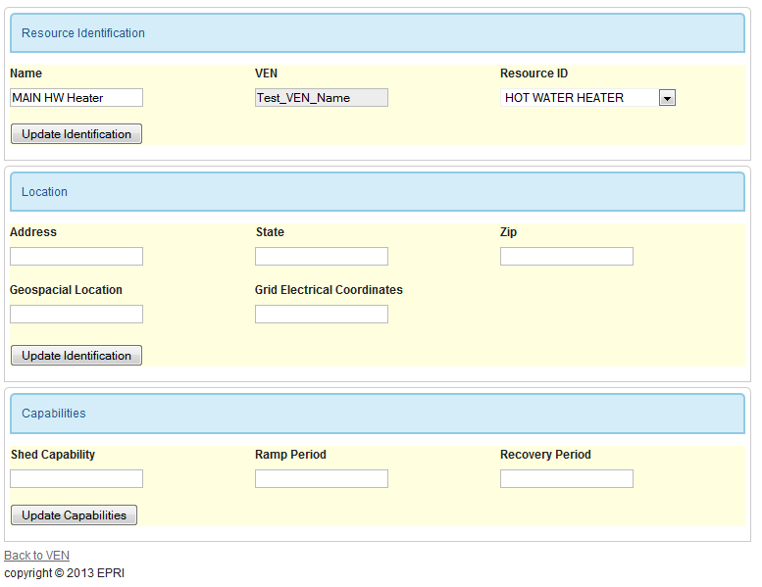
Figure 3-5
Resource Edit
Clicking the Add Resource button (see Figure 3-4) brings up Figure 3-6. A VEN can have any number of resources.
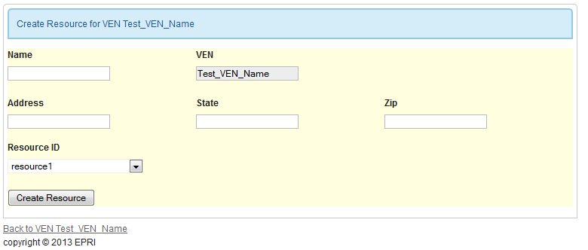
Figure 3-6
New Resource

Market Context Subscriptions
The Market Context Subscriptions list shows which market contexts the VEN is subscribed to (see Figure 3-7). In Figure 3-7, the VEN is subscribed to http://MarketContext 1 and not subscribed to http://MarketContext2. The user can subscribed or unsubscribe by pressing the associated button.
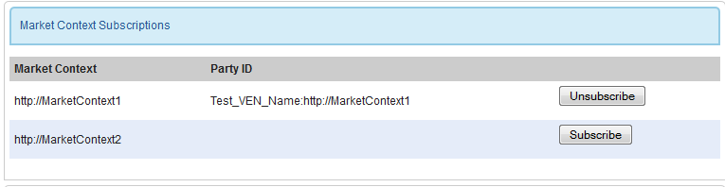
Figure 3-7
Market Context Subscriptions
When subscribed to a market, the VEN is assigned a unique Party ID which is a combination of the VEN Name and the Market Context ID. This party ID can be selected by the admin when selecting Party ID targets (see Creating Events).
We realize that this is probably not how the alliance envisioned using Party ID. When a VEN subscribes to a Market Context, that VEN should automatically receive events that are created in that Market Context. In other words, the admin creating an event should not have to manually select specific party IDs.
There are other implications to consider: is a party ID something that should be kept private? In other words, when party IDs are added to an event, should every VEN that receives the event see the every party ID?

Reports
The reports list is a list of reports the VEN registered during the registration process.
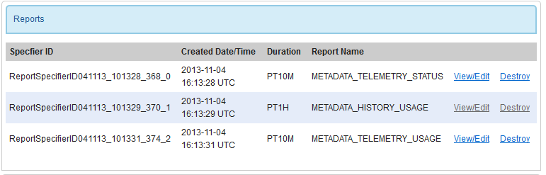
Figure 3-8
Report List
The view/edit screen shows the details of a report, including a description of the report intervals, and the most recent values for each interval as reported by the VEN. See Figure 3-9.
The report view page has three sections: report identification, report description, and report instances.

Report Identification
The report identification fields show the type of report (telemetry or history), duration, and the date/and time the report was created (as reported in the Open ADR message).

Report Description
The report description section shows what intervals are available in the report.

Report Instances
Report instances are actual data reports. While a report description describes the data points (or intervals) in a report, report instances report data values. The Report Instances section shows a list of the 5 most recent reports.
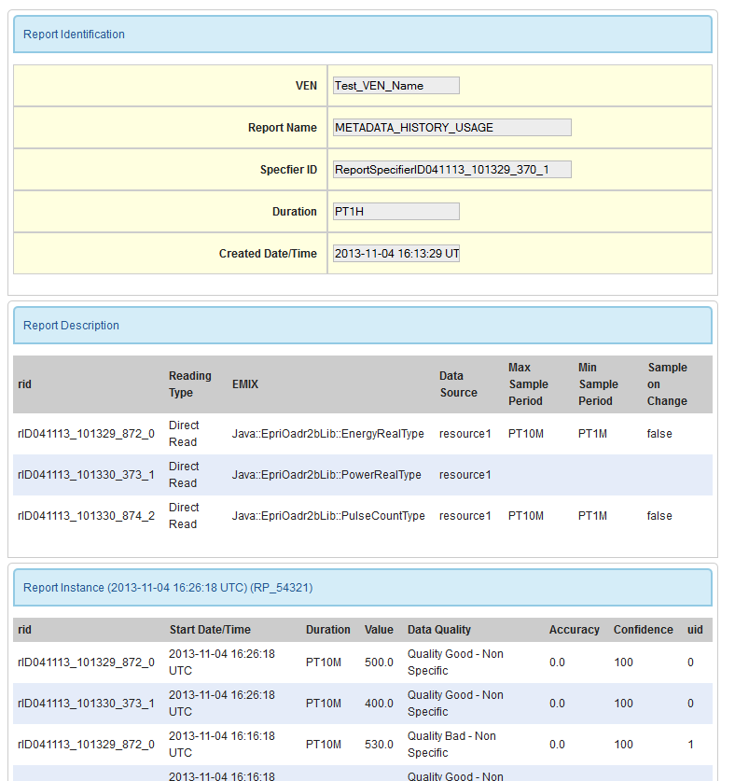
Figure 3-9
Report View

Report Requests
The VTN can request the VEN to report on any interval from any registered report by creating a Report Request. Figure 3-10 shows an example list of Report Requests.

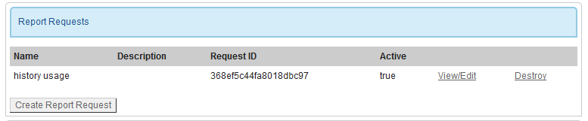
Figure 3-10
Report Requests
If a report request is active, the request has been sent to the VEN causing the VEN to send the report to the VTN at the interval requested in the report.
The following 3 sections describe how to create and edit requests, and how to send requests to a VEN, and cancel requests.

Create Report Request
Clicking the Create Report Request button opens the new Report Request Screen. See Figure 3-11.
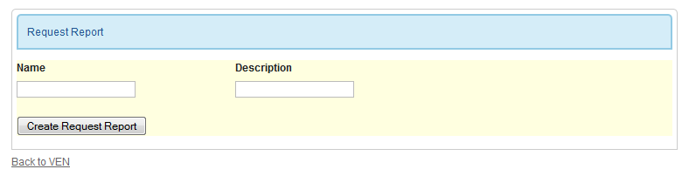
Figure 3-11
New Report Request
To create a new request, click the Create Report Request button in the Report Request list (see Figure 3-10). The new Report Request screen is displayed. See Figure 3-11.
Both the name and description fields are for information only to aid in identifying report requests on the VTN. These fields re not used by OpenADR. Clicking the Create Request Report button opens the new Report Request in the edit/view page.

View/Edit Report Request
The top of the Report Request view/edit page is a list of Report Requests identical to the list of requests displayed on the VEN show page (see figure 3-10). The list is repeated here as a convenience.
The next section, Report Request Identification, identifies the Report Request that is being viewed/edit. See Figure 3-12.

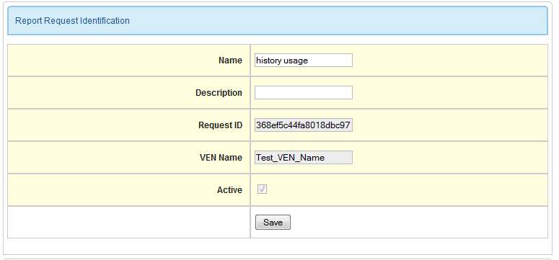
Figure 3-12
Report Request Identification
In the Report Identification section, the user can modify the name and description. The Request ID is a unique ID used by the VEN to identify a request.

Add Intervals to a Report Request
Report requests specify which report to grab intervals from via the ReportSpecifierID and which intervals should be reported via rID. In the current implementation, specific intervals in a report cannot be requested: all intervals will be requested.
The following values can be specified:
- Granularity: minutes between samples. The rate at which the VEN should sample the value.
- Start Date/Time: the date/time the VEN should start collecting samples for reporting purposes.
- Duration: duration in minutes from the start date/time to continue reporting.
- Reportback Duration: how often to send the report back to the VTN.

Send and Cancel a Report Request
The next section contains a buttons for sending Report Request to the VEN, or cancelling a previous request. See Figure 3-13.
Once the Report Request is configured, the user should send the request to the VEN by clicking the Send Report button.
To cancel a report request that was previously sent to a VEN, click the Cancel Report button. Select the Report to Follow checkbox if the VEN should still send the next report.
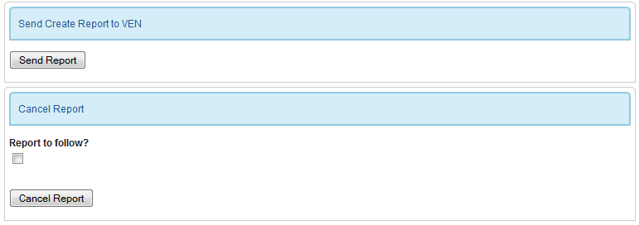
Figure 3-13
Send and Cancel Report Request

Opt Schedules
The Opt Schedules list displays all of the opt schedules the VEN has sent to the VTN. See figure 3-14.
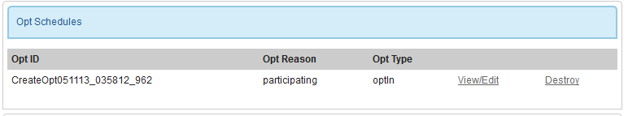
Figure 3-14
Opt Schedules List
Click the view/edit link to view the details of an Opt Schedule. Figure 3-15 shows an example Opt Schedule view/edit page.
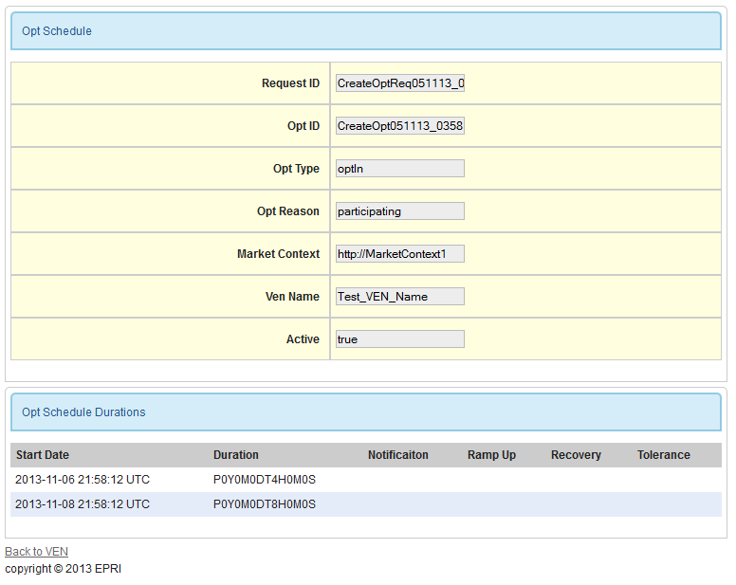
Figure 3-15
Opt Schedule View
Opt schedules provide a mechanism for a VEN to indicate availability to a server. In Figure 3-15, the VEN states that it is available (Opt Type is optIn) with a reason of participating. The VEN is available during two time periods: 1 is 4 hours long and the other is 8 hours long.
If a VEN cancels an opt schedule, the Active flag will turn to false.

VEN Registration Details
The final section on the VEN page is the registration details. If a VEN isn’t registered, there will be no information below the VEN Registration Details box. See Figure 3-16.
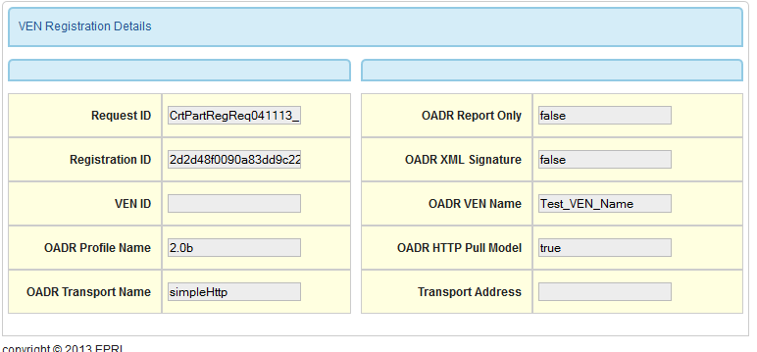
Figure 3-16
Registration Details
Before a profile b VEN can communicate with the VTN, the VEN must go through a registration process. The registration details tells the VTN what profile the VEN is using (2.0a or 2.0b) and the transport its using (simpleHttp or xmpp). If the VEN is using the simpleHttp transport and OADR HTTP Pull Model is false, messages will be pushed to the VEN over HTTP to the registered Transport Address as soon as the message becomes available.

Creating An account
Only Admin users can create an account. To create an account,
- Select accounts link from the user menu and click the Create Account button. See Figure 4-1.
- In the New Account screen, enter the user name, password, password confirmation, and optional e-mail address. See Figure 4-2. The password must be at least 6 characters long and password and password confirmation must match.
- Once the account is created, the user is redirected to the view/edit page of the new account. See Figure 4-3. From the view/edit page, the user’s password can be changed, and the user can be promoted to admin or demoted. The other fields are informational only and not required.

Non-admin users will not see the Administrator Settings and non-admin accounts are blocked from updating this field.

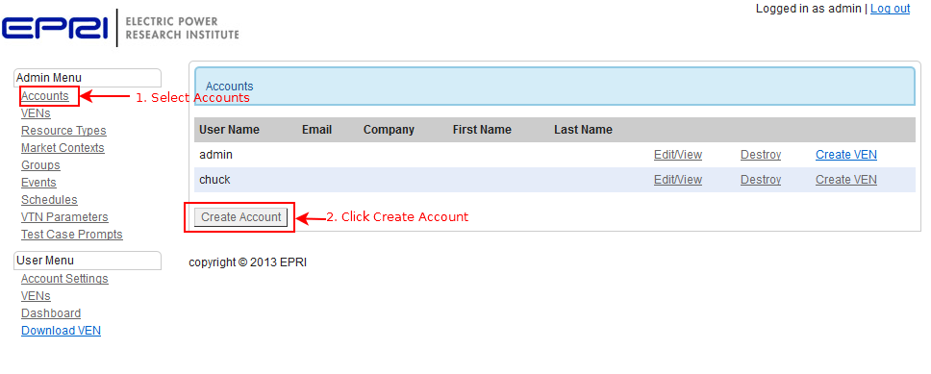
Figure 4-1
Create Account step 1: Click accounts, Create Account

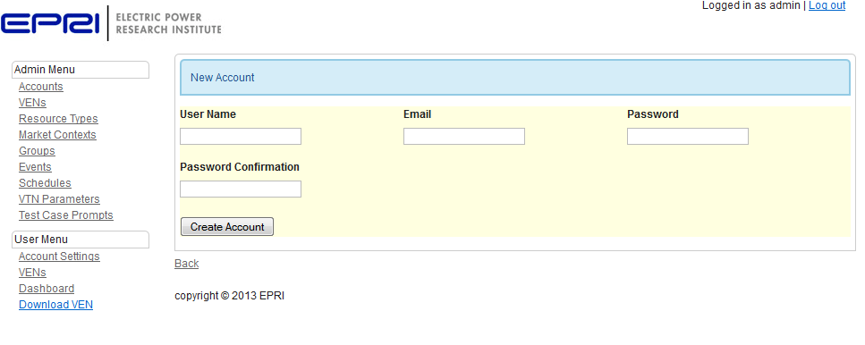
Figure 4-2
Create Account step 2: fill out the form

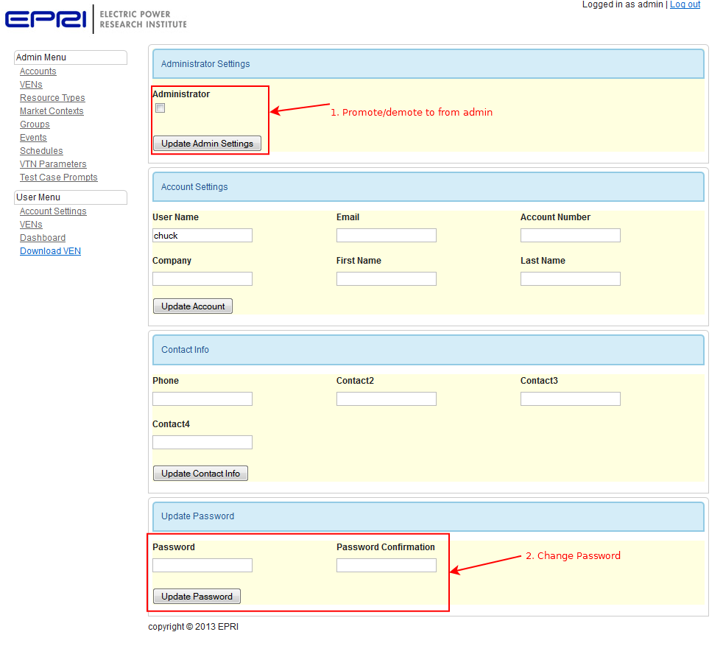
Figure 4-3
Create Account Step 3: promote/demote to/from admin, change password

Creating a VEN
The following steps guide the reader through creating a VEN.

- There are two ways to reach the Create New VEN screen:
  - Admin users can select Accounts and then click Create VEN to create VEN for a particular account. See Figure 5-1.
OR
  - Admin users and regular users can select the VEN link and then click the Create VEN button at the bottom of the VEN list. See Figure 5-2. This button will create a VEN for the logged in account. See Figure 5-2.
Following (a) or (b) above opens the new VEN page. See Figure 5-3.
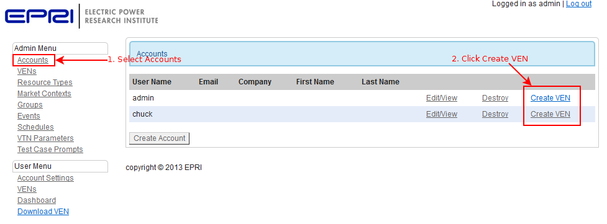
Figure 5-1
Create a VEN step 1 (admin): click Accounts and click Create VEN

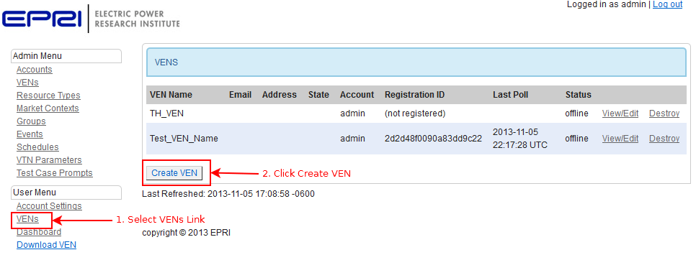
Figure 5-2
Create a VEN step 1 (users): click VENs and then click Create VEN

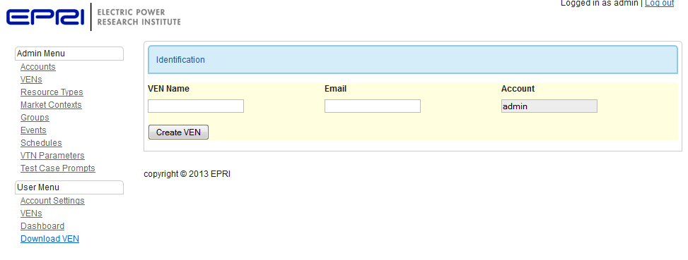
Figure 5-3
Create VEN step 2: Fill in a unique VEN Name
(…new VEN continued, step 2)
- From the new VEN screen, fill in a unique VEN Name and click Create VEN. The VEN view/edit page is displayed. See Configuring/Managing VENs.

Creating an Event
Only admin users can create an event. Non-admin users can create test events by following the Create Test Event link (see Figure 6-1), but the user cannot modify any details of the event (for security reasons) after it has been created.

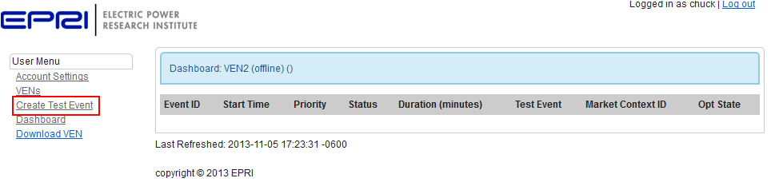
Figure 6-1
Creating a test event
Admin users can create an event as follows:
- Select Events from the menu and then click Create Event (see Figure 6-2). The New Event Screen is loaded (see Figure 6-3).
- Fill in the event details and signal interval values. All of these items can be modified after the event has been created. Click Create Event. The Event view/edit screen is loaded. The top of the view edit screen contains two buttons: Publish Event and Cancel Event. These buttons are covered later.
- The next sections are Event Settings and Response Required (see Figure 6-3). The event settings are high level attributes of an event. See the OpenADR profile specifications for detailed information on these fields. The response required field determines if the VEN should send a response to the VTN after the VEN receives the event.
- Below the Response Required section is the Event Signals list (see Figure 6-4). A signal or baseline can be added to the event by clicking the Add Signal or Baseline button. Remove a signal by clicking the destroy link next to a signal/baseline. Clicking the Add Signal or Baseline button loads the New Event Signal/Event Baseline screen. See Figure 6-5).
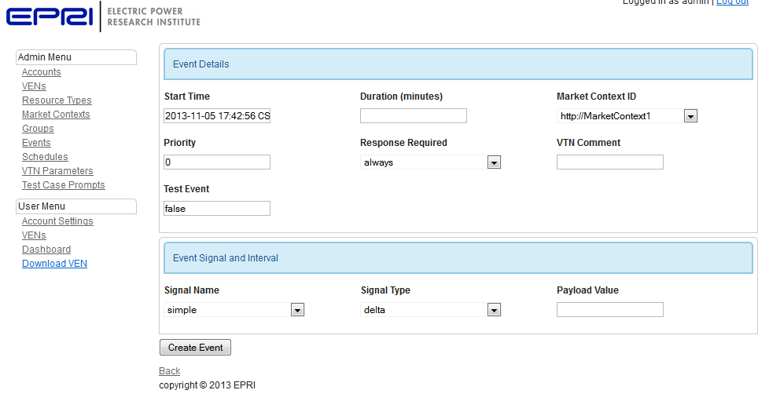
Figure 6-2
Create Event step 2: fill in the event details. These attributes can be modified later as needed

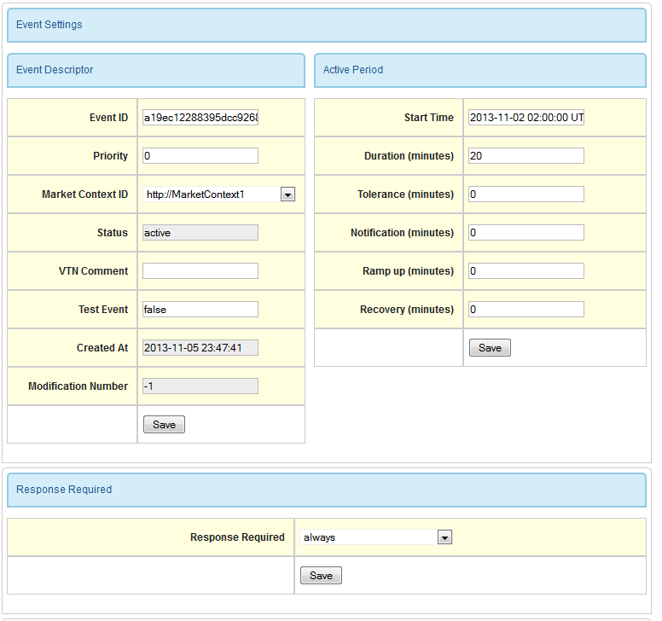
Figure 6-3
Create event step 3: fill in event Settings

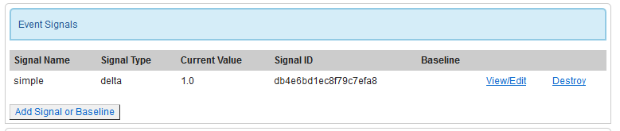
Figure 6-4
Create event step 4: add signals and intervals
(… create Event continued)
- From the New Event Signal/Event Baseline screen, fill in the appropriate signal or baseline attributes and click the associated button. The Event Signal page loads.
- From the Event Signal page, the user can change the attributes of the signal (or baseline) and add intervals to the signal. The top of the screen shows the details of the Event for which the signal (or baseline) belongs. See Figures 6-6 and 6-7. The duration of the intervals in a signal or baseline must sum to the duration of the event.
- Add and remove intervals from the signal (or baseline) by modifying the intervals section (see Figures 6-6 and 6-7). The sum of the duration of the intervals must match the duration of the event.

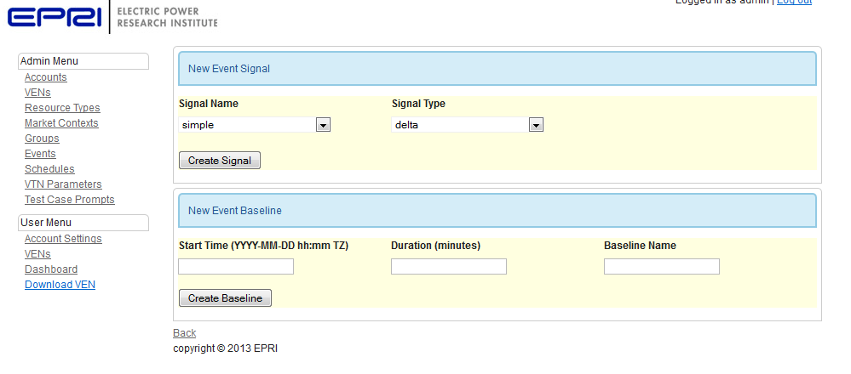
Figure 6-5
Create event step 4: add a signal or baseline
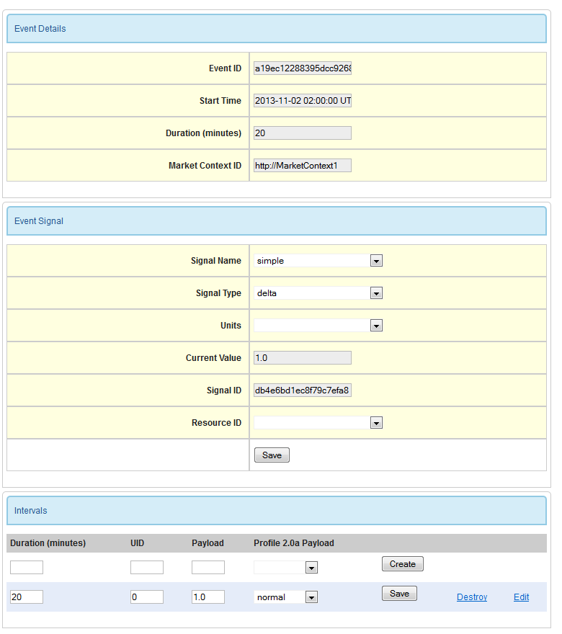
Figure 6-6
Create an event step 6: Edit an Event Signal
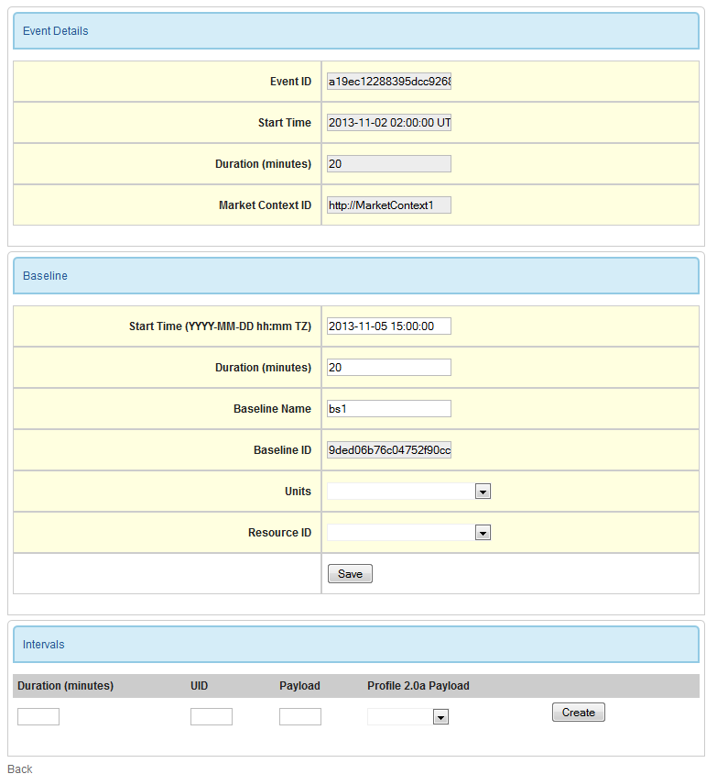
Figure 6-7
Create an event step 6: Edit an event baseline
(… create Event continued)
- After configuring the signals and intervals, return to the Event view/edit screen by clicking the ‘Back’ link at the bottom of the Event Signal screen. The Back link can be seen at the bottom of Figures 6-6 and 6-7). Scroll to the bottom of the Event view/edit page. The last section on the page is Targets. See Figure 6-8. Targets determine which VENs will receive the event.

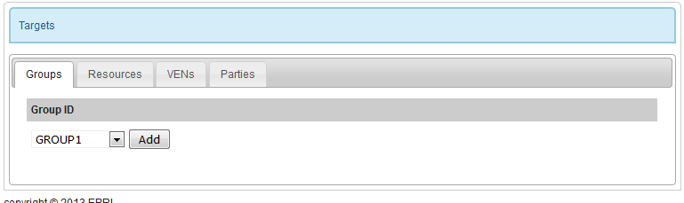
Figure 6-8
Create event step 8: add targets
(… create Event Continued)
- Once you are finished modifying the event, scroll to the top of the event page. Since the event has been modified (or newly created), it is in an unpublished state as indicated by the warning message (see figure 6-9). Press the Publish Event button to make the event available to VENS
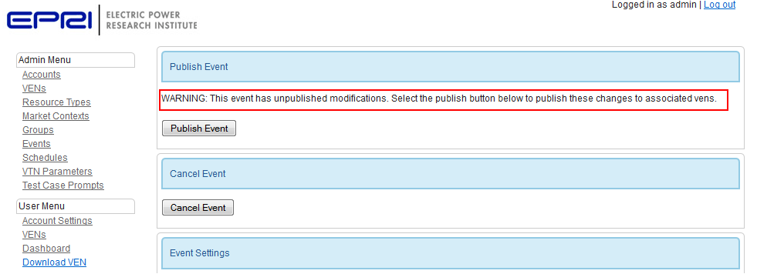
Figure 6-9
Create Event step 9: warning indicates the event is not published. Press Publish Event to make the event available to targeted VENs

Signals and Intervals
Intervals in a signal become active in order based on the interval’s UID. The UID must start with 0 and increment by 1. The system does not enforce this rule.
A single event can target 2.0a and 2.0b VENs. When an event is generated for a 2.0a VEN, the following rules apply:
- 2.0a supports only one signal so only the first signal will be in the event message sent to the VEN
- 2.0a supports the ‘simple’ name only. Signals are hard coded to use this name.
- 2.0b introduces a few new signal types. If a signal type is selected that isn’t supported by 2.0a, the signal type defaults to LEVEL
- 2.0a limits the payload values to numbers between 0 and 3 inclusive. To support these payload values, intervals contain a Profile 2.0a Payload field that is sent to 2.0a VENs (see the Intervals section in Figures 6-6).
The UID field in an interval determines the order in which intervals become active. The active interval determines the Current Value field of an Event Signal.
UIDs must start with 0 and increment by 1. The system does not enforce this rule.
See the OpenADR profile specification for more information on compatibility between profile 2.0a and 2.0b. The documents can be downloaded from the alliance website at http://www.openadr.org.

Creating A Schedule
Creating a schedule is similar to creating an event. Schedules add two new sections to the event view/edit page: Schedule Duration and Event Start Time and Schedule. See Figures 7-1 and 7-2.
The list of schedules can be accessed by clicking the Schedules link (see Schedules under section 2). Besides these two additional sections, editing a schedule is the same as editing an event.
A service that executes on the server watches schedules and determines when an event should be created. An event is created when the current time matches the start time of the event minus the max of (0, Notification, Ramp up) (in minutes).
The server time zone is used for schedules.

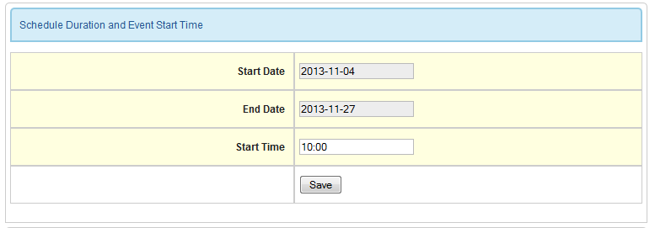
Figure 7-1
Schedule Duration and Event Start Time

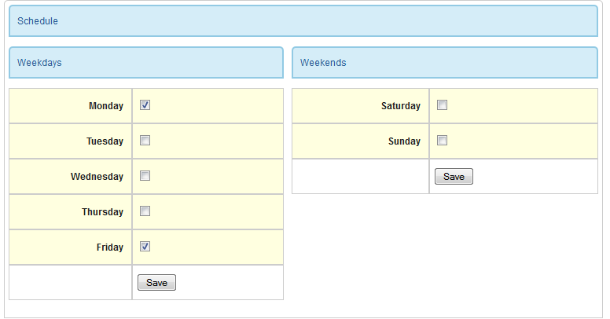
Figure 7-2
Event Schedule

User Menu
Non admin users have limited access to the system. The user menu consists of 5 links: Account Settings, VENs, Create Test Event, Dashboard, and Download VEN. See figure 8-1.
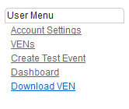
Figure 8-1
User Menu

Account Settings
Users can modify their account details and change their password from the Account Settings page. Users will see the same information shown in Figure 4-3, minus the admin settings at the top of the page.

VENs
The user VENs link lists all of the VENs associated with the logged in account. The user can manage existing VENs, create a new VEN or delete an existing VEN. See section 3 for information on managing VENs.

Create Test Event
Users can create test events through the Create Test Event link. The Create Test Event page has the same options as the Create Event page (see Figure 6-2).
Once a test event is created, non-admin users cannot modify any aspects of the event. The event will be marked as a test event and all VENs registered with the account will be listed as targets.

Dashboard
The dashboard provides an overview of the status of the logged in user’s VENs. For each VEN, the dashboard shows the VEN Name, status, and last communication time. Below the VEN status is a list of events that target the VEN.
The dashboard page refreshes automatically every 5 seconds. The bottom of the screen shows the last time the page was refreshed.
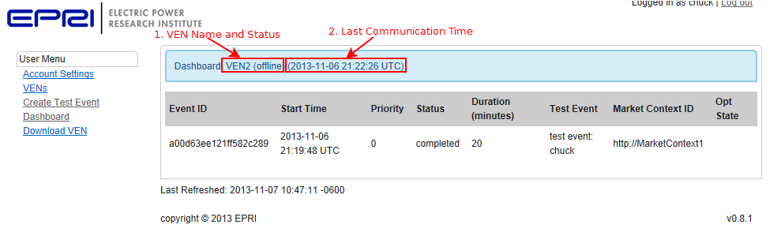
Figure 8-2
The Dashboard

Download VEN
The final link under the user menu is a link to download a VEN. Please see Download the VEN under section 1 for more information.

Running Test cases against the test set
The Test Case Prompt link aids in testing with the Quality Logic test harness. The test harness more than 60 EiEvent test cases, each of which has requirements for creating and modifying events. The prompts on this page will automatically create and modify events as needed by the test set.
To configure the VTN for testing with the test harness, follow the instructions under VTN Parameters and Test Case Prompts in Section 2.

installation

Installation Notes

EPRI’s OADR VTN was developed and tested on an Ubuntu 12.04 desktop and server. Limited testing has been done on Mac OSX. The software has not been tested on Windows Server, though all of the software used to run the OADR VTN runs on Windows. The following instructions are for Ubuntu Server 12.04.

Configuring Torquebox, MySQL, and Apache is a complex process. The following instructions are meant as a guideline for running the OADR VTN, not a template for securing a production environment.

It is advisable to not expose the OADR VTN outside your firewall if SSL is not turned on as the OpenADR services (EiEvent, EiReport, EiOpt, and EiRegisterParty) do not perform authentication. The services assume SSL authentication with client side certs has been performed before messages reach them. The OADR VTN is designed to be deployed behind an Apache reverse proxy which handles SSL.

Setup and Configure the Server
- Install Java 7: sudo apt-get install openjdk-7-jdk
- Setup the database:
  - The default database is PosgreSQL. Ubuntu installation instructions can be found here: https://help.ubuntu.com/community/PostgreSQL. Any Active Record supported database can be used, but the application is written and tested with PosgreSQL
  - create a database for the application
  - create a user for the application and give the user full rights to the database created in step b
- Setup a torquebox user and install torquebox
  - wget http://torquebox.org/release/org/torquebox/torquebox-dist/3.0.0/torquebox-dist-3.0.0-bin.zip
  - adduser torquebox –disabled-login
  - mkdir /opt/torquebox
  - chown torquebox:torquebox /opt/torquebox
  - sudo su torquebox
  - unzip torquebox-dist-3.0.0-bin.zip –d /opt/torquebox
  - cd /opt/torquebox
  - ln –s torquebox-3.0.0 current
- Add the following lines to the torquebox user’s ~/.bashrc file:
export TORQUEBOX_HOME=/opt/torquebox/current
export JBOSS_HOME=$TORQUEBOX_HOME/jboss
export JRUBY_HOME=$TORQUEBOX_HOME/jruby
PATH=$JBOSS_HOME/bin:$JRUBY_HOME/bin:$PATH

If java7 isn’t the default java
- SOURCE ~/.bashrc

Setup the Application
You should be running as the torquebox user.

- Copy oadr.knob to /home/torquebox/oadr and unzip the file: unzip oadr.knob
- At this point, you should be in the directory /home/torquebox/oadr. If you receive errors running the following commands, double check the export paths above are set correctly and torquebox is installed correctly.
- Install rails: gem install rails
- Install the application gems: RAILS_ENV=production bundle install
- Configure the application database:
  - Copy config/database.yml.example to config/database.yml
  - Edit config/database.yml. Under production: set the appropriate database, username, password, and host
- Setup a secret token:
  - Generate a secret: rake secret
  - Copy the output from the above command to: config/initializers/secret_tokent.rb
  - The last line in secret_tokent.rb should look like this:
Oadr::Application.config.secret_token = ‘place token here’
- Setup the database: RAILS_ENV=production rake db:schema:load
- Seed the database: RAILS_ENV=production rake db:seed
- Load test case prompts (if desired): RAILS_ENV=production rake db:loadtests
- Deploy the application to production: torquebox deploy –env=production
- Test the installation by running torquebox: torquebox run –b 0.0.0.0. This will start torquebox listening on all local interfaces on port 8080, allowing you to test that that application is working. After verifying that the login screen loads, hit <ctrl+c> to stop torquebox
- Install torquebox upstart scripts: rake torquebox:upstart:install. Running this command will warn you that certain actions couldn’t be completed. As the root user, follow the instructions.
- Edit /etc/init/torqubox.conf: towards the end of the script, there’s a path to standalone.sh that’s missing ‘current’. Change the path to:
/opt/torquebox/current/jboss/bin/standalone.sh
- Start torquebox through upstart: sudo start torquebox
- Verify torquebox is running by tailing the log file: tail –f /var/log/torquebox/torquebox.log. Application log files are /home/torquebox/oadr/log/[production,oadr].log
- By default, torquebox will listen on 127.0.0.1. To make the application available outside the localhost, change the inet-address parameter in /opt/torquebox/current/jboss/standalong/configuration/standalone.xml

After starting torquebox, check that the application started without issue by looking at the torquebox log file in /var/log/torquebox/torquebox.log. Look for errors like this:
(NameError) missing class or uppercase package name (‘epri.oadr2b.lib.OadrPayload’)

This error indicates torquebox is finding the wrong JVM; the application will not run under Java 6. You may need to uninstall Java 6. On Ubuntu, run the following command to make Java 7 the default:
sudo update-alternatives –config java

After running the above command, you will be presented with a list of options. Type the number that corresponds to Java 7 and press enter.

Setup and Configure Apache with SSL
EPRI’s OpenADR VTN is designed to run behind an SSL reverse proxy. Additionally, the OpenADR endpoints require client certificates signed by certain certificate authorities. Access to the server should only be allowed through the proxy.
This section outlines the steps required to setup Apache as a reverse proxy with SSL and client certificate authentication on Ubuntu 12.04. These directions assume some familiarity with Apache and OpenSSL.
- Install Apache: apt-get install Apache2
- Enable the Apache modules for SSL and proxies by executing the following commands
a2enmod proxy
a2enmode proxy_http
a2enmod rewrite
a2enmod ssl
- Obtain a server certificate from the NetworkFx website: http://www.networkfx.net/netfx/
- Create the directory /etc/apache2/ssl/ca
- Unzip the file from NetworkFX. The zip contains 4 files (see figure 10-1): the root CA certificate (TEST_OpenADR_RSA_RCA0001_Cert.crt), the CA certificate for your server (TEST_OpenADR_RSA_SPCA0002_Cert.crt), a certificate signed by your CA to be used by your server (TETS_RSA_VTN_13082984729_cert.crt), and the private key associated with your server’s certificate (TEST_RSA_VTN_13082984729_privkey.der).
- Copy the two CA certificates to /etc/apache2/ssl/ca.
- Change to /etc/apache2/ssl/ca and run
c_rehash .
- Copy the certificate and the private key file to /etc/apache2/ssl/
- Make all of the files under SSL readable and writable by root only: change to /etc/apache2/ssl and run
chmod –R 600 *
- The documentation directory in the knob file contains to apache site files: oadr-ssl and redirect. The redirect file redirects requests on port 80 to 443. The oadr-ssl file sets Apache as a reverse proxy which sends proxies requests to http://localhost:8080 and it handles SSL. All connections require SSL, and any request which goes to /OpenADR2 (the OpenADR endpoints) require a client certificate that was signed by either of the CA certificates.
Copy the Apache site files to /etc/apach2/sites-available and modify the dns name and configure the redirect as needed for your configuration. Point the SSL parameters in oadr-ssl to the correct files.
- Enable the files by creating symlinks in the directory /etc/apache2/sites-enabled/
- Restart apache: service apache2 restart

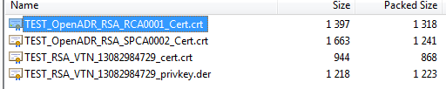
Figure 10-1
VTN Test Certificates from NetworkFx

The instructions above use test certificates from NetworkFx. The same instructions can be done with production certificates or self-signed certificates.

Setup and Configure OpenFire (XMPP) Server with SSL

Installation Resources
- Running torquebox on Debian: http://www.headlondon.com/our-thoughts/technology/posts/installing-torquebox-application-server-on-debian
- Apache in front of Rails: http://www.scatmania.org/projects/ssl-client-certificate-authentication-in-ruby-on-rails/
- Additional Apache with SSL sites:
- http://dev.mensfeld.pl/2013/06/jenkins-behind-apache-with-https-proxy-pass-with-ssl/
- http://whatimean.wordpress.com/2008/02/20/ssl-for-apache-and-rails
- Verifying certificates with OpenSSL:
- https://kb.wisc.edu/middleware/page.php?id=4064
- https://kb.wisc.edu/middleware/page.php?id=4543

Export Control Restrictions  Access to and use of EPRI Intellectual Property is granted with the specific understanding and requirement that responsibility for ensuring full compliance with all applicable U.S. and foreign export laws and regulations is being undertaken by you and your company. This includes an obligation to ensure that any individual receiving access hereunder who is not a U.S. citizen or permanent U.S. resident is permitted access under applicable U.S. and foreign export laws and regulations. In the event you are uncertain whether you or your company may lawfully obtain access to this EPRI Intellectual Property, you acknowledge that it is your obligation to consult with your company’s legal counsel to determine whether this access is lawful. Although EPRI may make available on a case-by-case basis an informal assessment of the applicable U.S. export classification for specific EPRI Intellectual Property, you and your company acknowledge that this assessment is solely for informational purposes and not for reliance purposes. You and your company acknowledge that it is still the obligation of you and your company to make your own assessment of the applicable U.S. export classification and ensure compliance accordingly. You and your company understand and acknowledge your obligations to make a prompt report to EPRI and the appropriate authorities regarding any access to or use of EPRI Intellectual Property hereunder that may be in violation of applicable U.S. or foreign export laws or regulations. | The Electric Power Research Institute, Inc. (EPRI, www.epri.com) conducts research and development relating to the generation, delivery and use of electricity for the benefit of the public. An independent, nonprofit organization, EPRI brings together its scientists and engineers as well as experts from academia and industry to help address challenges in electricity, including reliability, efficiency, affordability, health, safety and the environment. EPRI also provides technology, policy and economic analyses to drive long-range research and development planning, and supports research in emerging technologies. EPRI’s members represent approximately 90 percent of the electricity generated and delivered in the United States, and international participation extends to more than 30 countries. EPRI’s principal offices and laboratories are located in Palo Alto, Calif.; Charlotte, N.C.; Knoxville, Tenn.; and Lenox, Mass.  Together…Shaping the Future of Electricity
© 2013 Electric Power Research Institute (EPRI), Inc. All rights reserved. Electric Power Research Institute, EPRI, and TOGETHER…SHAPING THE FUTURE OF ELECTRICITY are registered service marks of the Electric Power Research Institute, Inc. | 10xxxxx

